奖学金年度评审流程Annual Review Process

1. 进入成都中医药大学国际学生在线服务系统，网址为https://cdutcm.17gz.org Open the [Chengdu University of Traditional Chinese Medicine Online Service Platform for International Students ,](https://cdutcm.17gz.org/)the link is https://cdutcm.17gz.org
2. 注册并登陆账号，详情查看注册指南 Register and log in to your account, see the registration guide for details

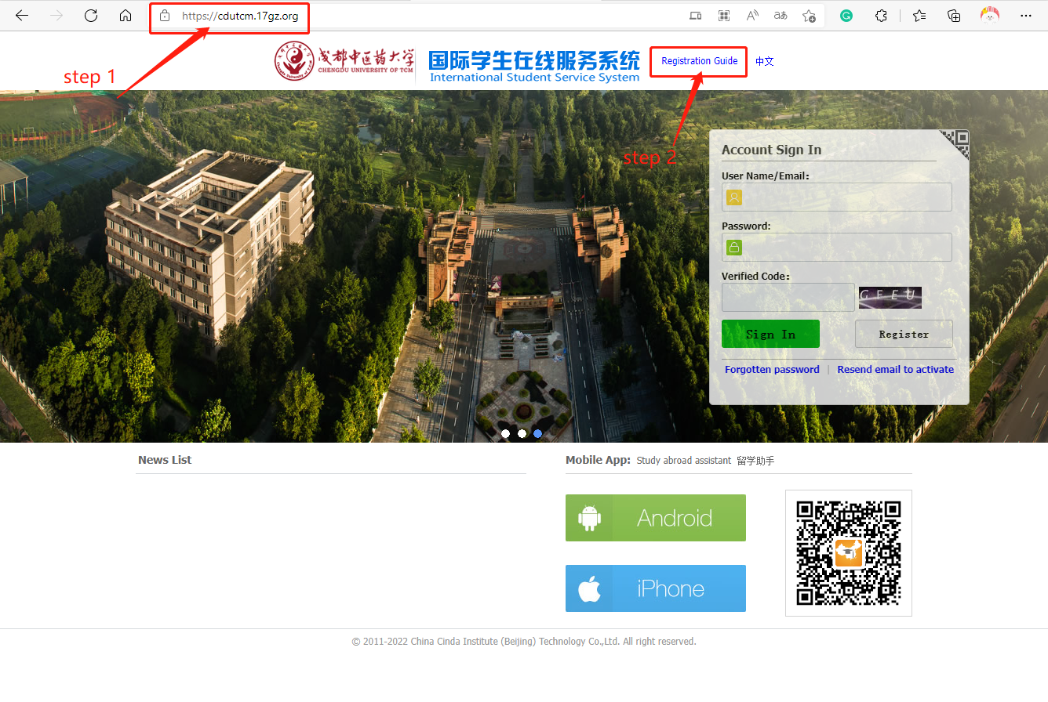

1. 将账号与学号绑定 Bind the account with your roll number

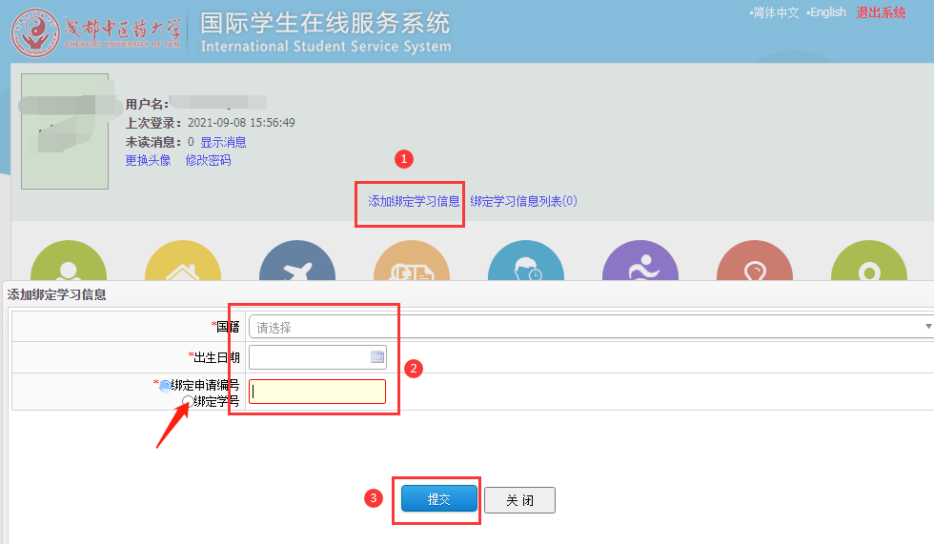

1. 绑定完成后，点击奖学金评审进行自评 After the binding, click Scholarship Review to conduct self-assessment

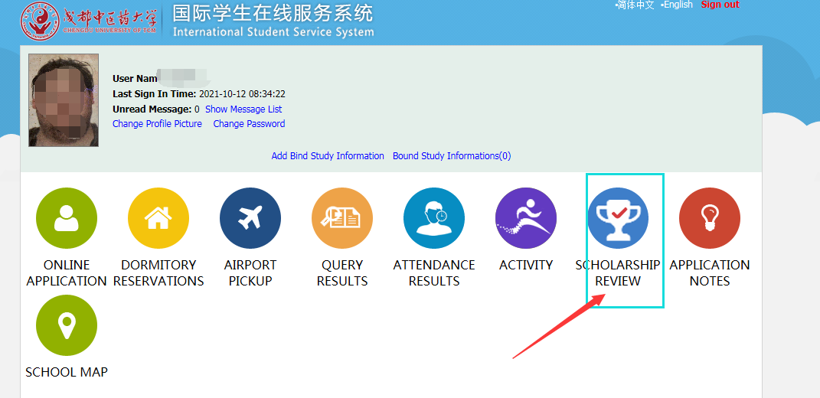

1. 填写自我评价的内容并上传相关附件后，点击提交。请在2022年5月9日17:00前点击提交。After filling in the content of the self-evaluation and upload the relevant attachments, click submit. Please click submit before 17:00 on May 9, 2022.

